Andrew Stites

EEE 64 – CpE64 Section 2

Wednesday

Lab 6-7

Samuel Wekanda

Lab Objective/Goal: Utilize multisim and an actual bread board, using a logic circuit (gates), to prove two DeMorgan's theorems.

Lab Preparations and Challenges:

I utilized the same file for multisim to configure a NAND gate and connected it to a LED on the LED bar. To complete the DeMorgan’s theorem proof for the NAND gate, I created a double inverted input to OR gate and connected that to a LED on the LED bar. All of the LED lights lit up when all except the double HIGH input. I created a new logic circuit that started with a NOR gate connected to a LED of a LED bar. To complete the DeMorgan’s theorem for the NOR gate, I created a double inverted input to AND gate and connected that to a LED on the LED bar. I tested all the inputs starting with double LOW, which resulted with both LED’s lighting up. The rest of the inputs yielded no LED’s to light up.

Lab Results:

**DeMorgan’s Theorem using a NAND gate and an inverted inputted OR gate:**

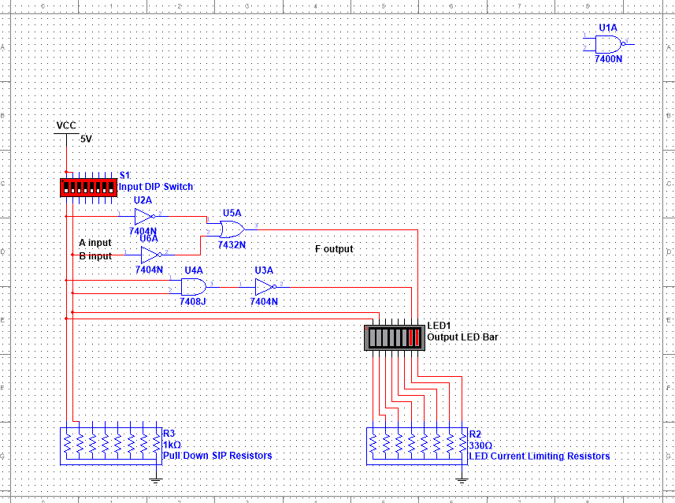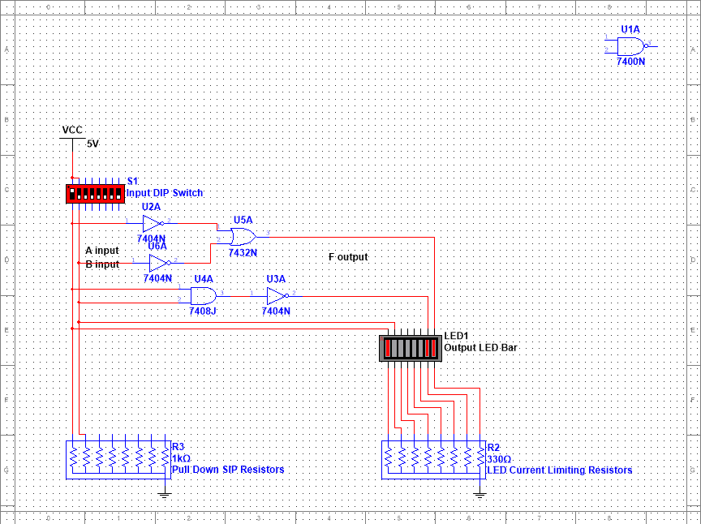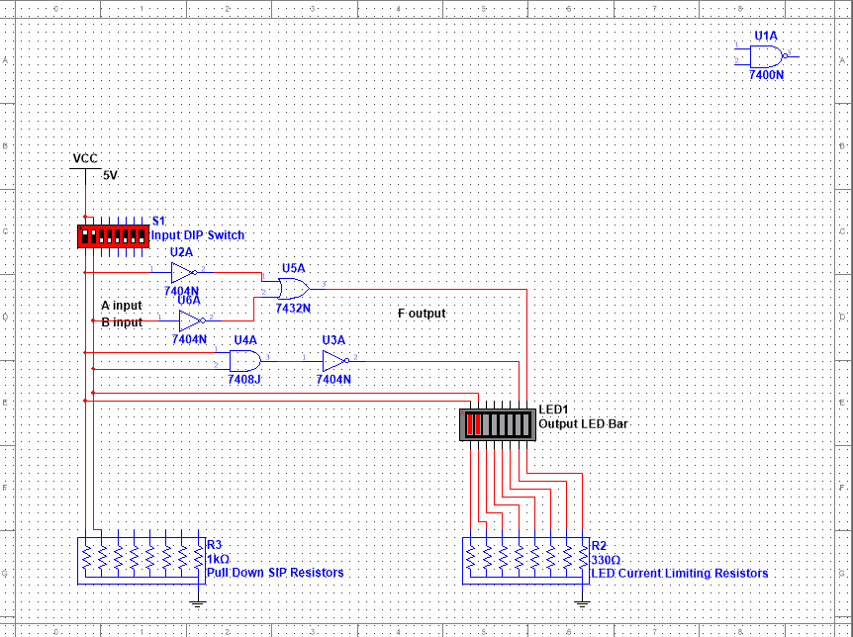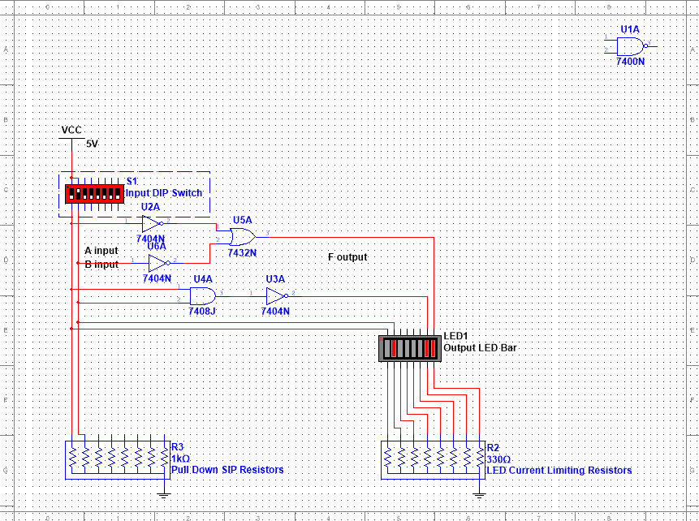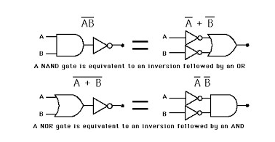

|  |  |  |  |
| --- | --- | --- | --- |
| A | B | ~(AB) | ~A+~B |
| 0 | 0 | 1 | 1 |
| 0 | 1 | 1 | 1 |
| 1 | 0 | 1 | 1 |
| 1 | 1 | 0 | 0 |

This is the multisim simulation of a double inverted input to OR gate and connected that to a LED on the LED bar. All of the LED lights lit up when all except the double HIGH input.

**DeMorgan’s Theorem using a NOR gate and an inverted inputted AND gate:**

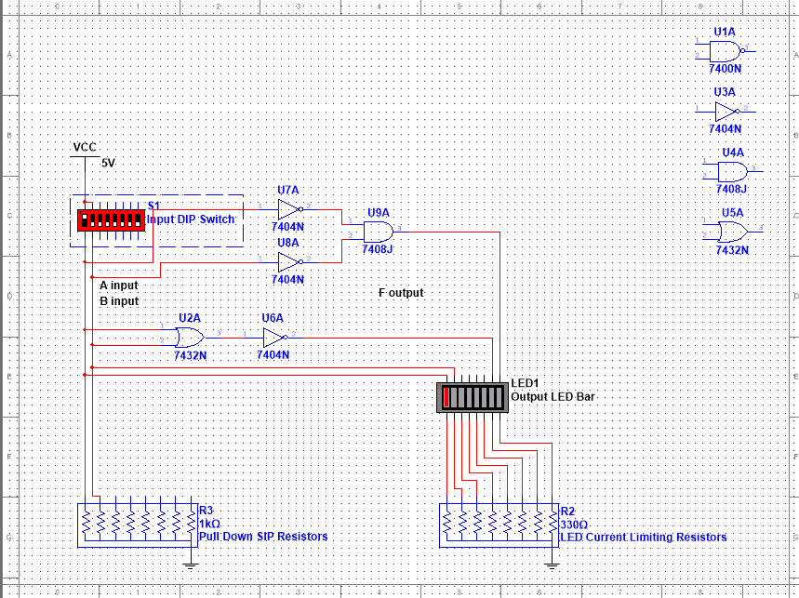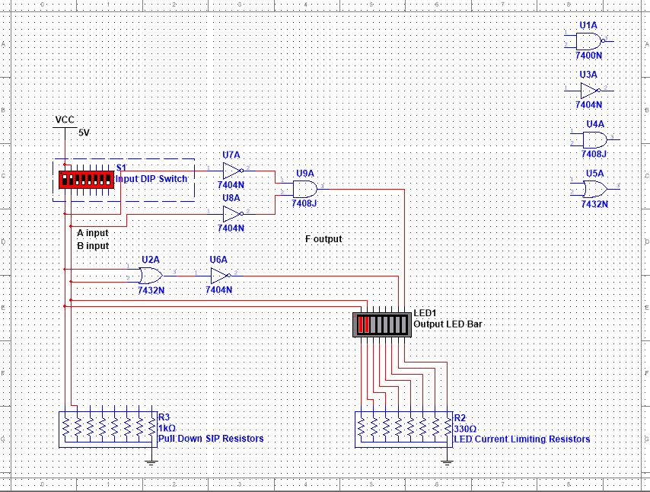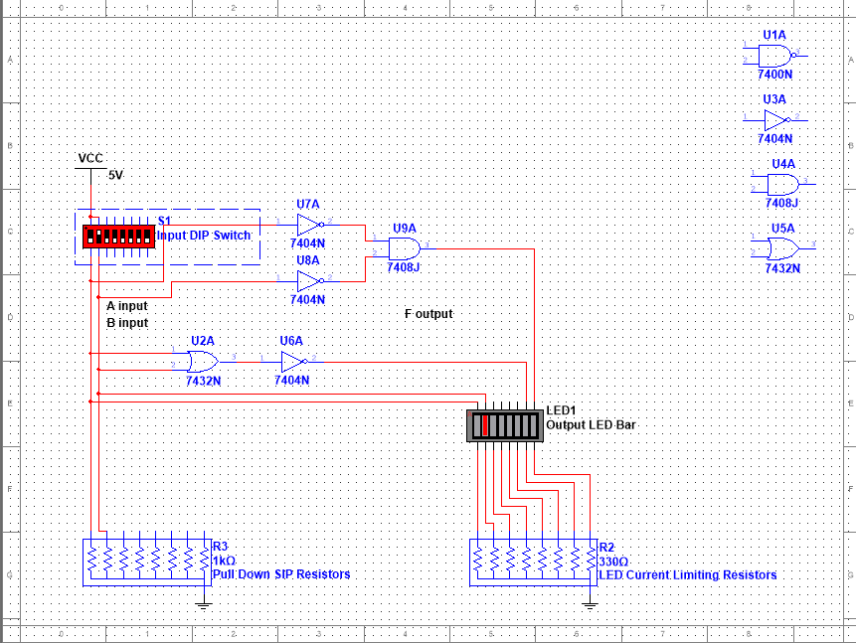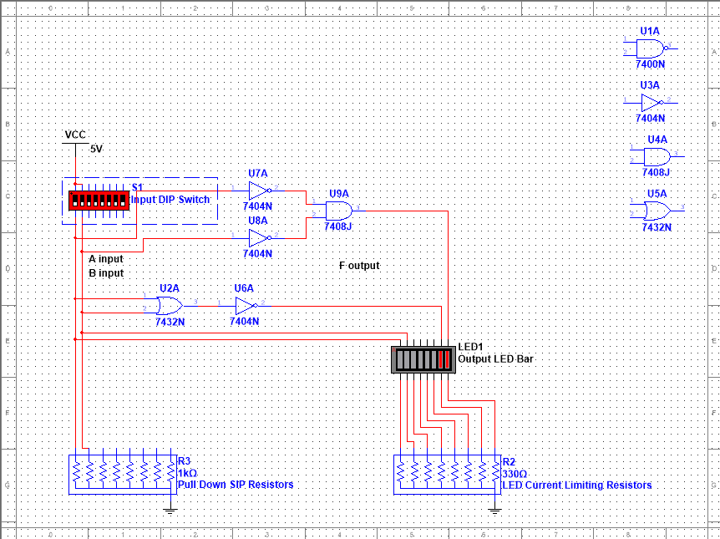

|  |  |  |  |
| --- | --- | --- | --- |
| A | B | ~(A+B) | ~A~B |
| 0 | 0 | 1 | 1 |
| 0 | 1 | 0 | 0 |
| 1 | 0 | 0 | 0 |
| 1 | 1 | 0 | 0 |

This is the multisim simulation of a double inverted input to AND gate and connected that to a LED on the LED bar. I tested all the inputs starting with double LOW, which resulted with both LED’s lighting up. The rest of the inputs yielded no LED’s to light up.

**Both Theorems on Actual Bread Board:**

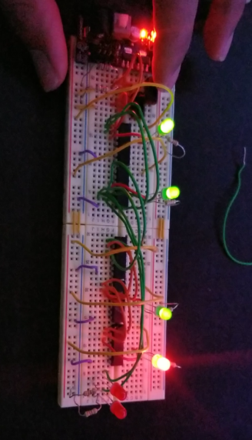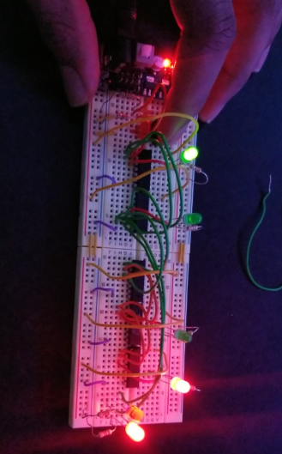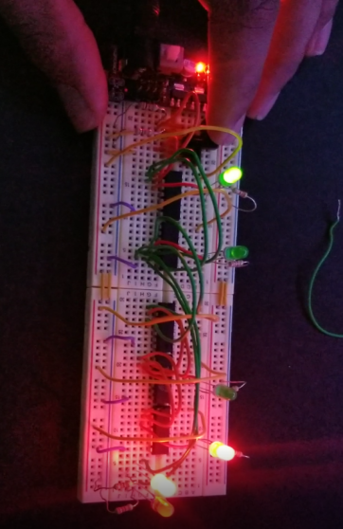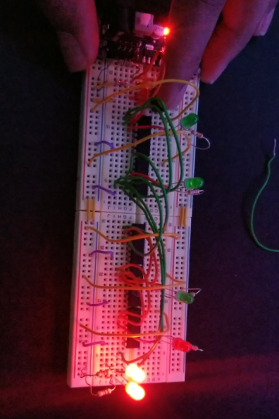

|  |  |  |  |  |  |
| --- | --- | --- | --- | --- | --- |
| A | B | ~(A+B) | ~A~B | ~(AB) | ~A~B |
| 0 | 0 | 1 | 1 | 1 | 1 |
| 0 | 1 | 0 | 0 | 1 | 1 |
| 1 | 0 | 0 | 0 | 1 | 1 |
| 1 | 1 | 0 | 0 | 0 | 0 |

The gates are in order of NAND, NOR, INVERTER, AND, and OR. The NAND and NOR are connected to their own LED’s with 330 Ohm resistors. The INVERTER is connected to the AND and the OR gate which are connected to their own LED’s.

**Truth Table for Actual Bread Board and Multisim:**

**MultiSim** **BreadBoard**

|  |  |  |  |  |  |  |  |  |  |
| --- | --- | --- | --- | --- | --- | --- | --- | --- | --- |
| A | B | ~(A+B) | ~A~B | ~(AB) | ~A~B | ~(A+B) | ~A~B | ~(AB) | ~A~B |
| 0 | 0 | 1 | 1 | 1 | 1 | 1 | 1 | 1 | 1 |
| 0 | 1 | 0 | 0 | 1 | 1 | 0 | 0 | 1 | 1 |
| 1 | 0 | 0 | 0 | 1 | 1 | 0 | 0 | 1 | 1 |
| 1 | 1 | 0 | 0 | 0 | 0 | 0 | 0 | 0 | 0 |

Conclusion:

These labs were by far the easiest and most streamlined labs to date. When constructing the circuits in multisim, it went very quickly. Over time, I have become more comfortable with multisim and feel more confident with my understanding of the material in the lecture and the lab. I did have some trouble regarding the physical setup of the bread board due to the trouble of not having the LED’s light up properly unless I move the entire board around.Perhaps, if I had a better board, it wouldn’t have taken as long to complete the board.